Handling Imbalanced Data: Key Techniques for Better Machine Learning
What is Imbalanced Data?
Imbalanced data occurs when one class or category in a dataset is disproportionately represented compared to others. This can manifest in both binary classification problems (e.g., fraud detection where most transactions are legitimate, but a few are fraudulent) and multi-class classification problems (e.g., classifying species in an ecosystem where some species dominate).
For example, in a dataset of 10,000 instances where 95% belong to one class (Class 0), and only 5% belong to the other (Class 1), it’s clear that the model could focus heavily on the majority class, often ignoring the minority class entirely. This imbalance can mislead your model’s performance and skew the evaluation metrics.

Why is Imbalanced Data a Problem?
Imbalanced data poses several significant challenges in machine learning. Here’s a breakdown of the problems with examples:
- Misleading Accuracy:
- In an imbalanced dataset, the majority class dominates the model’s predictions, leading to high accuracy but poor performance for the. minority class. For instance, if 95% of your data is labeled Class 0, predicting all instances as Class 0 yields 95% accuracy, even if Class 1 predictions are entirely incorrect.
- Example: Consider a fraud detection system where 99% of transactions are legitimate and only 1% are fraudulent. A model that predicts all transactions as legitimate will achieve 99% accuracy but will fail to detect any fraud, rendering it useless for its intended purpose.
2. Poor Minority Class Performance:
- Models tend to underperform on the minority class, leading to poor recall (sensitivity) or precision for that class. A high recall in fraud detection means that most frauds are detected, but poor recall could result in many fraudulent transactions going unnoticed.
- Example: In a healthcare dataset where positive cases of a rare disease make up only 2% of the population, the model may classify all patients as negative, missing critical cases.
3. Skewed Evaluation Metrics:
- Metrics like accuracy become misleading when working with imbalanced datasets. Precision, recall, F1-score, and confusion matrices become more relevant, as they highlight the minority class’s performance more accurately.
- Example: In a customer churn prediction model, the accuracy might be high, but a deeper look at precision and recall shows the model fails to predict actual churners, which has business consequences.
4. Bias in Predictions:
- Machine learning algorithms inherently assume that all classes are equally important unless explicitly guided otherwise. This bias can manifest in poor predictions for the minority class if the algorithm is trained on imbalanced data.
- Example: In manufacturing, if a model is designed to detect defective items (which are rare), it may fail to identify defects if it hasn’t learned to properly prioritize minority instances in training.

Why Do Machine Learning Algorithms Perform Badly on Imbalanced Data?
- Skewed Loss Function:
Many algorithms optimize the overall accuracy or a global objective function that doesn’t take class imbalance into account. As a result, the minority class has little impact on the objective, leading to poor minority class predictions.
2. Majority Class Domination:
The algorithm tends to be biased toward predicting the majority class since it occurs more frequently, and minimizing errors on this class has a larger effect on reducing overall loss.
3. Difficulty in Separating Classes:
In imbalanced datasets, the minority class may be harder to distinguish due to the sheer volume of majority class examples, which overwhelms the decision boundaries during training.

Why is Imbalanced Data a Big Deal?
Imbalanced data is ubiquitous in real-world problems, especially in domains where the occurrence of certain classes is naturally rare but important. This makes it a critical issue that data scientists need to tackle effectively. Some key areas include:
- Medical and Healthcare: Detecting rare diseases (minority class) in patient populations is essential for saving lives.
- Fraud Detection: Financial fraud or cyberattacks occur in a small number of cases but have significant consequences.
- Manufacturing and Quality Control: Detecting faulty products in manufacturing processes, where most items are expected to be perfect.
- Customer Churn: Predicting which customers are likely to leave a service, a small fraction, but vital for business retention.
- Cybersecurity: Identifying rare malware attacks within a sea of legitimate network activity.
1. Data-Based Solutions
These techniques modify the dataset itself to make it more balanced, ensuring that the model can learn better patterns from both classes.
Under Sampling
Concept: Under sampling involves reducing the size of the majority class by randomly removing samples. The goal is to bring the class distributions closer to each other.
Why it’s useful: Under sampling forces the model to give equal attention to both the majority and minority classes, which can reduce bias and improve learning for the minority class.
Risks:
- Loss of information: By discarding samples, valuable information from the majority class may be lost.
- Overfitting: With fewer data points, especially if the dataset is already small, the model may overfit.
- Sampling bias: Non-random sampling can lead to biases that skew the model’s predictions.
Techniques:
- Random Under Sampling: Randomly removes samples from the majority class.
- Cluster-based Under Sampling: Groups majority class examples into clusters and removes samples from each cluster.
- Tomek Links: Removes samples from the majority class that are close to the minority class to clean decision boundaries.
Over Sampling
Concept: Over sampling involves increasing the number of examples in the minority class to match the majority class, often by duplicating existing data or creating synthetic data.
Why it’s useful: Provides more data points for the minority class, allowing the model to learn the characteristics of that class better and reducing bias toward the majority class.
Risks:
- Overfitting: Duplicating examples from the minority class increases the risk of the model learning from overly specific patterns.
- Increased data size: Oversampling increases the dataset size, which may lead to higher computational costs.
- Redundancy: Repeated samples can cause redundancy without adding meaningful new information.
Techniques:
- Random Over Sampling: Randomly duplicates examples from the minority class to balance the dataset.
- SMOTE (Synthetic Minority Over-sampling Technique): Creates synthetic data points for the minority class by interpolating between existing examples.
- ADASYN (Adaptive Synthetic Sampling): Similar to SMOTE, but focuses on generating synthetic samples for areas where the model has difficulty classifying the minority class.
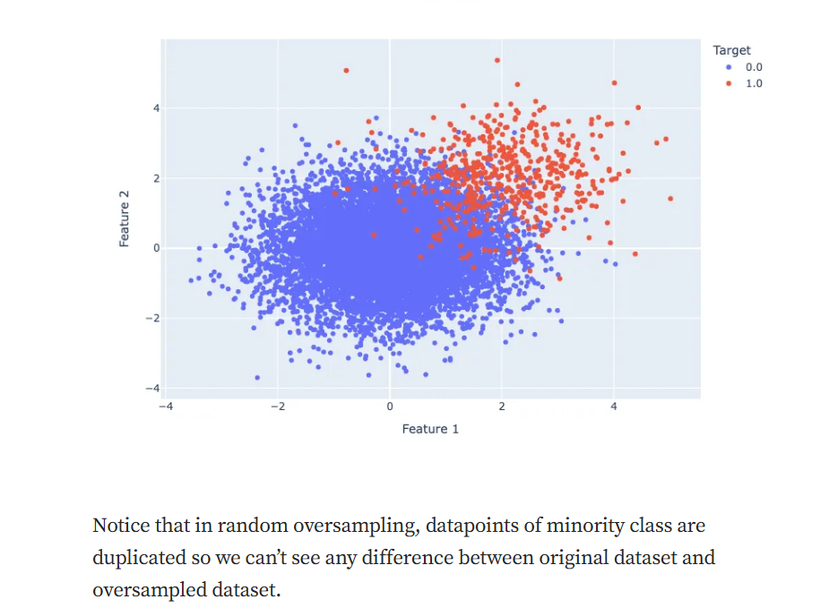

SMOTE (Synthetic Minority Over-sampling Technique)
Concept: SMOTE generates new synthetic data points for the minority class by interpolating between existing samples and their nearest neighbours. This technique avoids simply duplicating data and helps improve learning by introducing more variation.
How it works:
- Finds the k nearest neighbours for each minority class instance.
- Randomly selects a neighbour and generates a synthetic sample by interpolating between the original instance and the neighbour.
Benefits:
- Reduces overfitting: Unlike duplication, SMOTE adds variation by creating new synthetic examples.
- Improves minority class learning: By increasing the size of the minority class, models learn better and perform better on the minority class.
Risks:
- Boundary distortion: SMOTE may create synthetic examples near decision boundaries, potentially leading to class overlap.
- Computational cost: The process of generating synthetic data can be computationally expensive, especially for large datasets.
- 2. Algorithm-Based Solutions
- Algorithm-based approaches modify how models are trained to account for imbalanced data without altering the dataset itself.

- Class Weighting
- Concept: Most machine learning algorithms can assign different weights to classes, effectively making the minority class more “important” during training. This is particularly useful in classification algorithms like logistic regression or decision trees.
- Why it’s useful: It allows the model to focus more on the minority class without modifying the dataset, reducing the risk of overfitting and loss of information.
- Example: In a binary classification problem for fraud detection, the model might assign a higher weight to fraudulent transactions, encouraging the model to learn their patterns more effectively.

- Cost-Sensitive Learning
- Concept: In cost-sensitive learning, the model is trained with different misclassification costs for each class. Misclassifying the minority class (false negatives) is assigned a higher cost than misclassifying the majority class.
- Why it’s useful: Models become more sensitive to minority class predictions since the cost of misclassifying those instances is higher, leading to improved recall for the minority class.
- Example: In healthcare, where misdiagnosing a rare disease can have severe consequences, cost-sensitive learning ensures that the model prioritizes accurate identification of the minority class.

Ensemble Methods
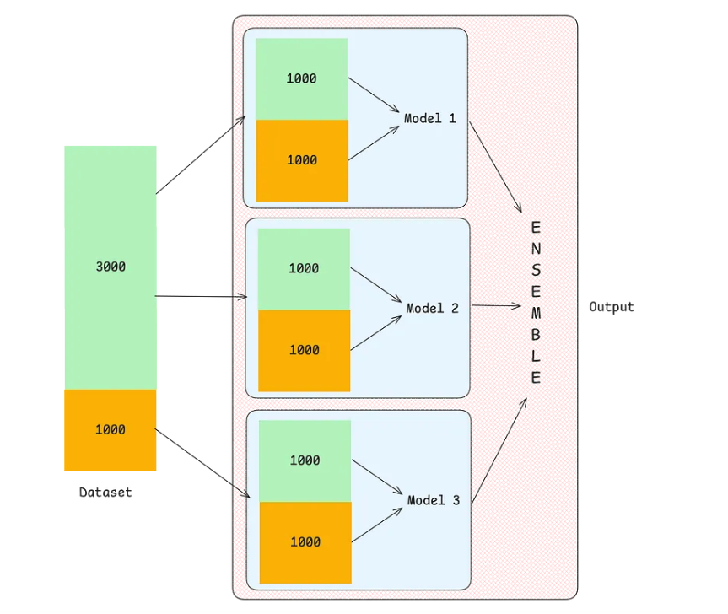
Ensemble methods combine the predictions of multiple models to improve performance. In the context of imbalanced data, several ensemble techniques from the imbalanced-learn (imblearn) library can be highly effective in addressing class imbalance:
BalancedRandomForestClassifier: This method combines random forests with balanced bootstrap samples. It ensures each tree in the forest is trained on balanced subsets of the data.
EasyEnsembleClassifier: It generates multiple under-sampled datasets and trains an ensemble of classifiers, effectively dealing with imbalance by focusing on different subsets of the majority class.
BalancedBaggingClassifier: Similar to bagging, but it uses balanced bootstrap samples, ensuring that each bootstrapped set has a balanced distribution of classes.
These techniques help models become less biased toward the majority class and improve generalization, especially for the minority class.

3. Tuning-Based Solutions
Tuning-based solutions involve adjusting the model’s decision-making threshold to improve its performance on the minority class.
Threshold Tuning
Concept: Instead of predicting based on the default probability threshold (often 0.5), threshold tuning adjusts this threshold to improve the model’s performance on the minority class.
Why it’s useful: When class distributions are imbalanced, using the default threshold may not work well. Lowering the threshold for the minority class ensures that more instances are predicted as the minority class, improving recall.
Example: In a spam detection system, if only 1% of emails are spam, lowering the threshold from 0.5 to 0.3 could improve the model’s ability to catch more spam emails.

